**Docker Commands from Lab 1.1**

**Project Scenario:**

1. Check docker services
2. Create file
3. Build image from container
4. Check image

**Practical Work:**

1. Make webpage with the name of index.html  
   make directory first with the name of lab2  
   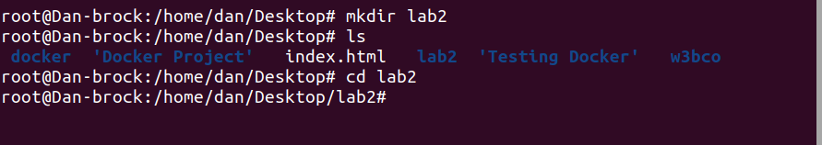  
   make new directory command **mkdir directory-name**

**$ sudo mkdir lab2**

**ls** command show all directories in current location **$ sudo ls**

enter in directory we used **cd** command **$ sudo cd lab2**

create index.html file with **touch** command

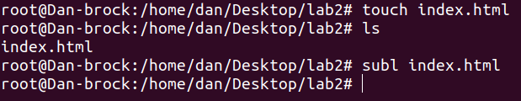  
**$ sudo touch index.html  
$ sudo ls**

Open index.html file & edit it

I used **sublime-text-3** that’s why I use here **subl index.html** for open this file on editor otherwise we used **vi or simple open** command

**$ sudo subl index.html / $ sudo vi index.html / $ sudo open index.html**

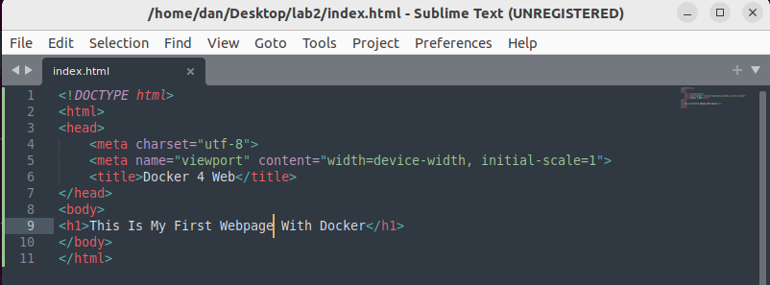

**Html syntax**

**<!DOCTYPE html>**

**<html>**

**<head>**

**<meta charset="utf-8">**

**<meta name="viewport" content="width=device-width, initial-scale=1">**

**<title>Docker 4 Web</title>**

**</head>**

**<body>**

**<h1>This Is My First Webpage With Docker</h1>**

**</body>**

**</html>**

create Dockerfile file with **touch** command  
**$ sudo touch Dockerfile  
$ sudo open Dockerfile**

Give Instructions

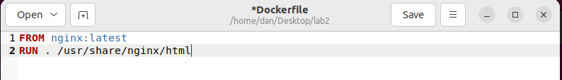  
**#Base OS  
#FROM OS:Tag  
FROM nginx:latest  
#Use library path from nginx  
#COPY <source><destination>  
COPY . /usr/share/nginx/html**  
Save & Exit

1. **Build image from Dockerfile**

Now Build a Image through Dockerfile

**$ sudo docker build -t webpage:latest .**

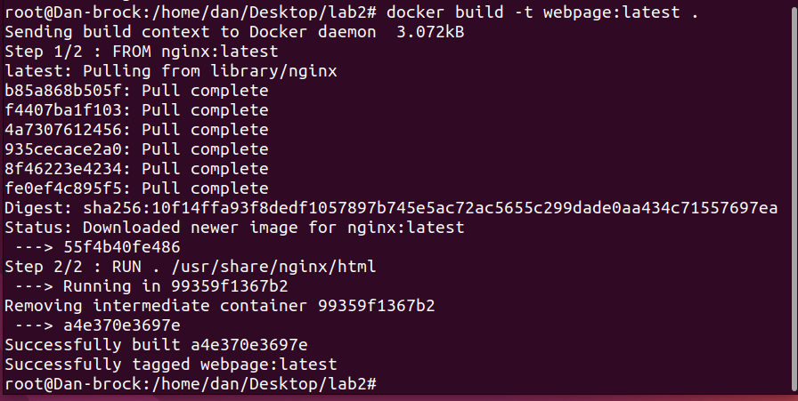  
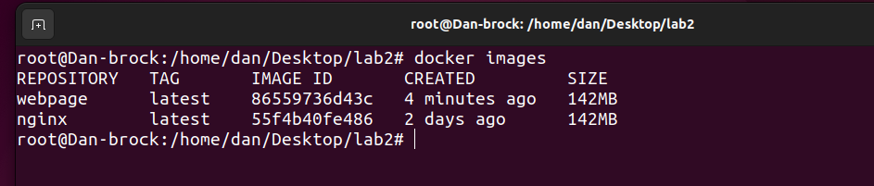  
**docker images** command show the list of your images

**$ sudo docker images**

1. **Create container of that image & give him ports**

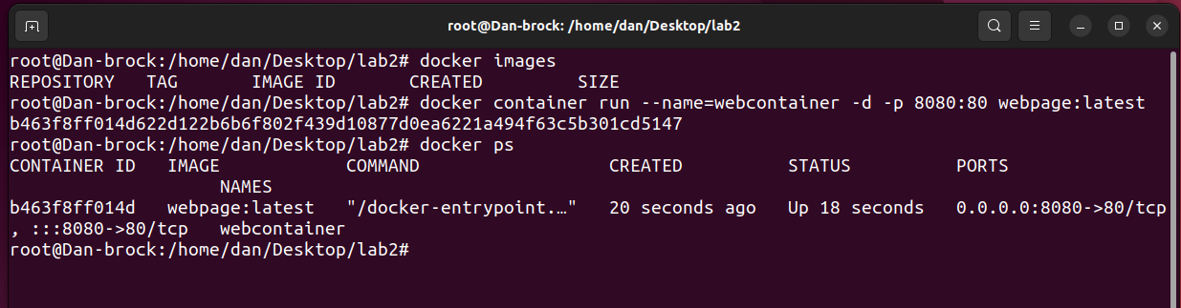

**$ sudo docker container run --name=webcontainer -d -p 8080:80 webpage:latest**

**$ sudo docker ps**

1. **Run on browser through localhost/port**

